1950

the field of computer vision emerged in 1950 with the invention of perceptrons by [Frank Rosenblatt](https://en.wikipedia.org/wiki/Frank_Rosenblatt)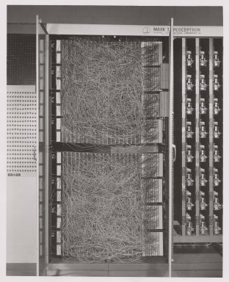

This machine was designed for image recognition which was seemed as the embryo of an electronic computer

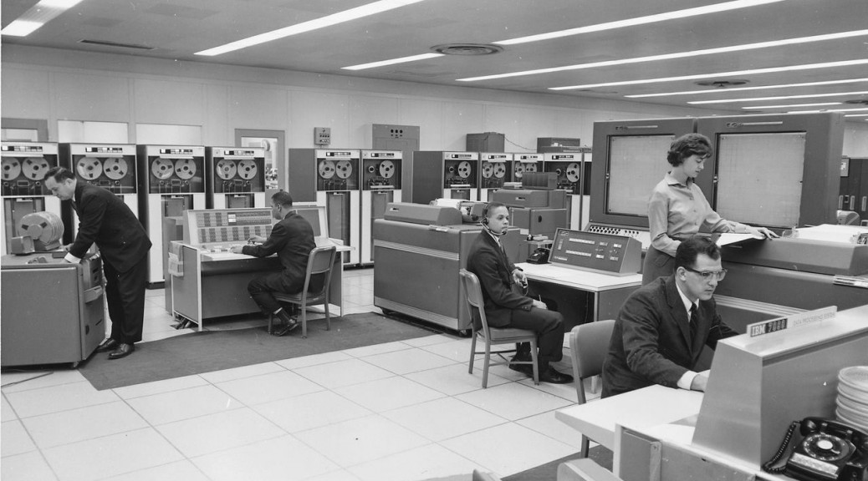

how it works: used 20×20 [cadmium sulfide](https://en.wikipedia.org/wiki/Cadmium_sulfide) [photocells](https://en.wikipedia.org/wiki/Photocell) to produce a 400-pixel image.

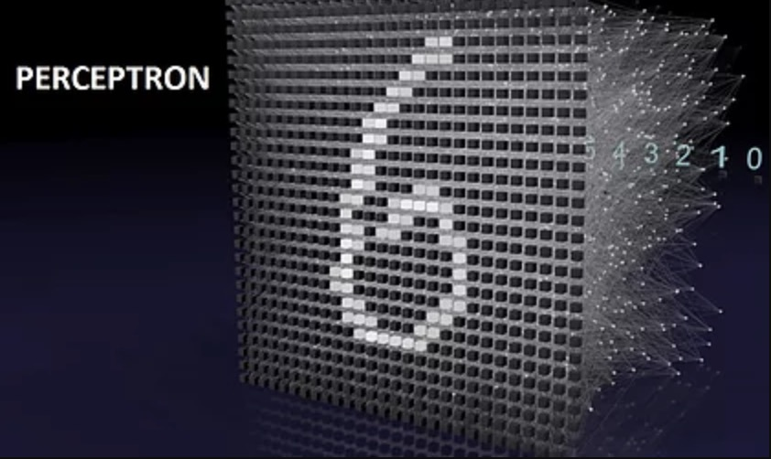

However, it is only capable of learning [linearly separable](https://en.wikipedia.org/wiki/Linearly_separable) patterns, like sort images into very simple categories like triangle and square.

1970

In 1970s,  [Marvin Minsky](https://en.wikipedia.org/wiki/Marvin_Minsky) and [Seymour Papert](https://en.wikipedia.org/wiki/Seymour_Papert) improved the algorithm of perceptrons. Studies in the 1970s formed the early foundations for many of the computer vision algorithms that exist today, including [extraction of edges](https://en.wikipedia.org/wiki/Edge_detection) from images, [polyhedral modeling](https://en.wikipedia.org/wiki/Polyhedron_model), and [motion estimation](https://en.wikipedia.org/wiki/Motion_estimation).

1990

Things started to heat up in the second half of the 90s due to the improvement on hardware. This decade saw the first use of statistical techniques to recognize [faces in images](https://en.wikipedia.org/wiki/Eigenface#History).

